Blue Partnership Action Fund
Project Proposal and Budget
I. Basic Information
1.1 Basic Project Information
Project Name
Project Implementation Area
Project Period
Proposed Budget from Blue Partnership Action Fund (USD/CNY)
Matching Amount and Sources (USD/CNY)
Total Project Budget (USD/CNY)
Full Name of the Applying Organization
Country of Registration
Project Applicant Types | Civil Society Organizations  Research Institutions  Non-profit Social Enterprises
Website / Social media homepage
Project Leader and Contact information

1.2 Project overview
(Please provide a concise summary of the project in no more than 200 words, including the basic content and highlight of the project)

1.3 Main topics of the project (Multiple selections are not allowed. Please put “√” at the designated position.)
 | a) | Mangrove conservation that aligns with development of eco-friendly livelihoods.
 | b) | Protection and restoration of other coastal ecosystems (seagrass, coral reefs, etc.).
 | c) | Marine biodiversity conservation and monitoring.
 | d) | Public outreach, citizen science or environmental education activities that related to the above topics.

1.4 Project team
Please list the key project staff, including personnel from partner organizations or external experts. Provide their job titles, roles, and specific responsibilities for this project, along with their credentials and relevant experience.

1.5 Project beneficiaries (people, species, regions)
Please explain the criteria for selection of and the identity of project beneficiaries

1.6 Project sustainability and scalability
Explain how the project will continue to deliver benefits and maintain its operations after the funding period, including plans for financial, environmental, and community support to ensure long-term success. Describe how the project could be scaled, and what are the conditions or resources required to scale.

II. Project Background
2.1 Basic information of the project implementation area:
Please specify the environmental or other status of the project implementation area, including the environmental issues addressed and their causes, threats and needs; and describe as specifically as possible the detailed geographical location related to the project (the project area location as map/kmz/kml/shape file should also be submitted), environmental status, key data and other information. Given the large amount of content, serial numbers should be adopted to list item by item.

  - What efforts have been made by other organizations (groups) in this area (issue):

2.3 Strategies for coping with the problem:
Applicants should elaborate on the basic strategies and steps to solve the above problems, and on how the above efforts in this field are coordinated or innovative, rather than simply repeating the established work. Strategies should focus on sustainability and consider the possibility of replication/promotion. It can be represented by a logic diagram. Given the large amount of content, serial numbers should be adopted to list item by item.

III. Project Objectives
What meaningful and positive results or changes will be achieved as the result of the implementation of the project? (Objectives must be specific and measurable.)

IV. Project Outputs and Activities
For the project objectives, corresponding outputs (indicators) should be listed. These outputs are to be presented to the project manager as a basis for project acceptance. Based on each project output, a series of project activities should be designed. Project outputs and activities should be consistent with the project budget sheet.
The relationship between project objectives, project outputs, and project activities is shown in the following diagram:
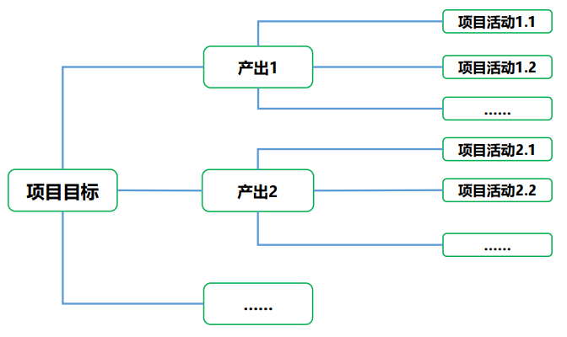
Project Objectives
Output 1
Output 2
Project Activity 1.1
Project Activity 1.2
Project Activity 2.1
Project Activity 2.2

Output 1
Output 1 measurable indicator
Specific activities to be performed in order to achieve the above outputs:
Project Activity 1.1 | Fill in the name of project activity
Implementation Period
Location of Activity
Activity Performers
Activity Details

Project Activity 1.2 | Fill in the name of project activity
Implementation Period
Location of Activity
Activity Performers
Activity Details

Output 2:
Output 2 measurable indicator
Specific activities to be performed in order to achieve the above outputs:
Project Activity 2.1 | Fill in the name of project activity
Implementation Period
Location of Activity
Activity Performers
Activity Details

Project Activity 2.2 | Fill in the name of project activity
Implementation Period
Location of Activity
Activity Performers
Activity Details

Please add more tables as needed

V. Stakeholder Analysis
Stakeholders refer to organizations or groups that share an interest in the project, such as communities and government agencies. Stakeholder analysis helps to unite possible actors to jointly address environmental issues, thus achieving project objectives.
Stakeholders  (List the main stakeholders/groups of the project) | Benefits  (The benefits the project will help them obtain) | Possible impact +/-  （Positive/negative） | Management  (How will the project ensure that stakeholders receive these benefits)

VI. Project Risk Analysis
Difficulties/risks are bound to be encountered during the implementation of any project. Please list possible risks and perform risk analysis and risk management.

Project Risk 1: XXXXXX ......
Likelihood of the risk: □High □Medium □Low
Which objective or activity of the project is affected by the risk:
Actions to be taken to address this risk:

Project Risk 2: XXXXXX ......
Likelihood of the risk: □High □Medium □Low
Which objective or activity of the project is affected by the risk:
Actions to be taken to address this risk:

Project Risk 3: XXXXXX ......
Likelihood of the risk: □High □Medium □Low
Which objective or activity of the project is affected by the risk:
Actions to be taken to address this risk:

VII. Monitoring and Evaluation Plan
The monitoring and evaluation plan is designed to encourage better management of project objectives and indicators by partners and to help them understand their own project results. We supports partners to achieve project monitoring and evaluation during the implementation of project, which can be carried out by the project team or by a third party invited.
Purpose of monitoring and evaluation  (e.g., project progress monitoring, effectiveness evaluation, impact evaluation, summary of knowledge and experience) | How to perform monitoring and evaluation  (How will the project be monitored and evaluated? Who will conduct the monitoring/evaluation? When/how often will monitoring/evaluation be performed? How to give feedback/summarize/share?)

VIII. Budget
 | Project Activities | Description of Expenses | Budget Details (type of cost, quantity * unit price, etc.) | Budget (USD)
1 | Example: Activity 1.1 | Example: Mangroves Restoration | Example: seedlings, or propagules ($786/ha) * 10 ha | 7860
2
3
4
 | Sub Total
 | Overhead |  | (Less than 10% of the total budget)
 | Total
Please add more lines as needed. If certain costs, like transportation or staff salaries, cover multiple activities, you may list them as overall expenses rather than splitting them by activity.

IX. Applicant’s Declaration
Collection of Personal Data:
Please note that by submitting this form which contains personal data (as defined in the Personal Data Protection Act 2012 (Singapore) (the “PDPA”) and Civil Code of the People’s Republic of China (CCC)), the Applicant hereby consents to the collection, use and/or disclosure of their personal data by us, for the purpose of the Project or any related activities they wish to participate in and related purposes, in accordance with the PDPA and CCC and granters’ data protection policy.

Truth Declaration:
I, the Applicant, declare that the information provided by my directors, officers, employees and/or agents on my behalf in this Project Proposal and Budget and all other documents associated with this grant application is true and accurate.
In the event that the information provided in this Project Proposal and Budget is found to be false or inaccurate in any way, I understand that (a) this application may be deemed as withdrawn or void, and/or (b) if the grant has been disbursed (in whole or in part), the grant may be terminated with immediate effect, and the applicant may be required to repay or return all grant disbursements to the granter.

IN WITNESS WHEREOF
___________________ (Applicant’s Name) has caused this Project Proposal and Budget to be duly executed by its authorized representative on the date set forth below.

SIGNED BY

_____________________________
Authorized Representative:
Designation:
Date:

