Blue Partnership Action Fund
Project Proposal and Budget
I. Basic Information
1.1 Basic Project Information
Project name
Project implementation area
Project cycle
Full name of the applicant
Applicant information Code
Application for funding of Blue Partnership Action Fund (in USD or RMB)
Funding and amount of other parties to the project (in USD or RMB)
Total project budget (in USD or RMB)
Project leader and contact information
Project Applicant Types | Civil Society Organizations (including NGOs, non-profit social enterprises, etc.)  Universities, research institutes, think tanks and other scientific research institutions;  Volunteer groups, etc.;  Others:

Project proposal submission time:
1.2 Project overview
(Please provide a concise summary of the project in no more than 200 words, including the basic content and the value of the project)

1.3 Main topics of the project (Multiple selections are not allowed. Please put “√” at the designated position.)
 | a) | Protection and restoration of coastal wetland ecosystems (mangroves, seagrass, coral reefs, etc.);
 | b) | Regional blue carbon trading mechanism;
 | c) | Marine biodiversity conservation and monitoring;
 | d) | Marine protected areas planning and monitoring;
 | e) | Marine ecological corridor survey and conservation;
 | f) | Marine microplastics and marine litter monitoring;
 | g) | Activities related to the above topics, such as marine environmental education and public outreach.

1.4 Project beneficiaries (people, species, regions)
(Please explain the criteria for selection of and the identity of project beneficiaries)

1.5 How the project reflects its public benefits
(What aspects of the project can prove that it is a public charity project)

II. Project Background
2.1 Basic information of the project implementation area:
Please specify the environmental or other status of the project implementation area, including the environmental issues addressed and their causes, threats and needs; and describe as specifically as possible the detailed geographical location related to the project (the project area location as map/kmz/kml/shape file should also be submitted), environmental status, key data and other information. Given the large amount of content, serial numbers should be adopted to list item by item.

  - What efforts have been made by other organizations (groups) in this area (issue):

2.3 Strategies for coping with the problem:
Applicants should elaborate on the basic strategies and steps to solve the above problems, and on how the above efforts in this field are coordinated or innovative, rather than simply repeating the established work. Strategies should focus on sustainability and consider the possibility of replication/promotion. It can be represented by a logic diagram. Given the large amount of content, serial numbers should be adopted to list item by item.

III. Project Objectives
What meaningful and positive results or changes will be achieved as the result of the implementation of the project? (Objectives must be specific and measurable.)

IV. Project Outputs and Activities
For the project objectives, corresponding outputs (indicators) should be listed. These outputs are to be presented to the project manager as a basis for project acceptance. Based on each project output, a series of project activities should be designed. Project outputs and activities should be consistent with the project budget sheet.
The relationship between project objectives, project outputs, and project activities is shown in the following diagram:
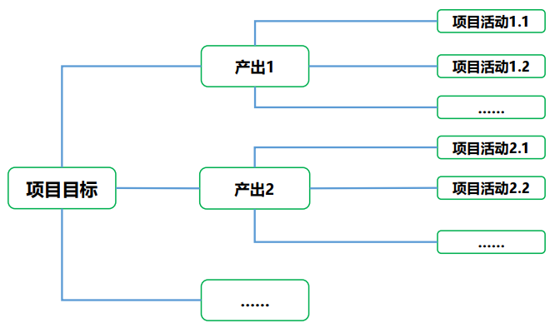
Project Objectives
Output 1
Output 2
Project Activity 1.1
Project Activity 1.2
Project Activity 2.1
Project Activity 2.2

Output 1:
Output 1 measurable indicator:
Specific activities to be performed in order to achieve the above outputs:
Project Activity 1.1: | Fill in the name of project activity
Activity Time:
Location of Activity:
Activity Performers:
Activity Details:

Project Activity 1.2: | Fill in the name of project activity
Activity Time:
Location of Activity:
Activity Performers:
Activity Details:

Output 2:
Output 2 measurable indicator:
Specific activities to be performed in order to achieve the above outputs:
Project Activity 2.1: | Fill in the name of project activity
Activity Time:
Location of Activity:
Activity Performers:
Activity Details:

Project Activity 2.2: | Fill in the name of project activity
Activity Time:
Location of Activity:
Activity Performers:
Activity Details:

(Please add information if necessary)
……

V. Stakeholder Analysis
Stakeholders refer to organizations or groups that share an interest in the project, such as communities and governments. Stakeholder analysis helps to unite possible actors to jointly address environmental issues, thus achieving project objectives.
Stakeholders  (List the main stakeholders/groups of the project) | Benefits  (The benefits the project will help them obtain) | Possible impact +/-  （Positive/negative） | Management  (How will the project ensure that stakeholders receive these benefits)

VI. Project Risk Analysis
Difficulties/risks are bound to be encountered during the implementation of any project. Please list possible risks and perform risk analysis and risk management.

Project Risk 1: XXXXXX ......
Likelihood of the risk: □High □Medium □Low
Which objective or activity of the project is affected by the risk:
Actions to be taken to address this risk:

Project Risk 2: XXXXXX ......
Likelihood of the risk: □High □Medium □Low
Which objective or activity of the project is affected by the risk:
Actions to be taken to address this risk:

Project Risk 3: XXXXXX ......
Likelihood of the risk: □High □Medium □Low
Which objective or activity of the project is affected by the risk:
Actions to be taken to address this risk:

VII. Monitoring and Evaluation Plan
The monitoring and evaluation plan is designed to encourage better management of project objectives and indicators by partners and to help them understand their own project results, and is not intended for review by the Society of Entrepreneurs and Ecology (the SEE). SEE supports partners to achieve project monitoring and evaluation during the implementation of project, which can be carried out by the project team or by a third party invited.
Purpose of monitoring and evaluation  (e.g., project progress monitoring, effectiveness evaluation, summary of knowledge and experience) | How to perform monitoring and evaluation  (How will the project be monitored and evaluated? Who will conduct the monitoring/evaluation? When/how often will monitoring/evaluation be performed? How to give feedback/summarize/share?)

VIII. Budget
 | Type of Cost | Budget details (type of cost, quantity * unit price, etc.) | Budget (in USD or RMB)
1 | Example: Mangroves Restoration | Example: planting of seeds, seedlings, or propagules (US$786/ha) * 10 ha | 7860 USD
2
3
4
Sub Total
Overhead |  | 10% of the total budget
Total

